**Name:** D. Ashwanth Ram

**Reg No:** 3122 21 5001 013

—------------------------------------------------------------------------------------------------------------------

**Assignment-02: Intermediate Code Generation using LEX and YACC**

---------------------------------------------------------------------------------------------------------------------

**Aim :-**

**To implement Intermediate Code Generation using LEX and YACC**

**Code :-**

**Intermediate.l :-**

%{

#include "y.tab.h"

#include <stdio.h>

#include <stdlib.h>

#include <string.h>

%}

%%

"and" { return AND; }

"or" { return OR; }

":=" { return ASSIGN; }

"+" { return PLUS; }

"-" { return MINUS; }

"*" { return MULT; }

"/" { return DIV; }

"<" { return LT; }

"(" { return LPAREN; }

")" { return RPAREN; }

";" { return SEMICOLON; }

[0-9]+ { yylval.num = atoi(yytext); return NUM; }

[a-zA-Z][a-zA-Z0-9]* { yylval.id = strdup(yytext); return ID; }

[ \t\n]+ { /* ignore whitespace */ }

. { printf("Unknown character: %s\n", yytext); }

%%

int yywrap() {

return 1;

}

**Intermediate.y :-**

%{

#include <stdio.h>

#include <stdlib.h>

#include <string.h>

int temp_count = 0; // Counter for temporary variables

int label_count = 100; // Counter for labels

int new_temp() { return temp_count++; }

int new_label() { return label_count++; }

void emit(const char* op, const char* arg1, const char* arg2, const char* result) {

if (strcmp(op, "=") == 0) {

printf("%s = %s\n", result, arg1);

} else if (arg2) {

printf("%s = %s %s %s\n", result, arg1, op, arg2);

} else {

printf("%s = %s %s\n", result, op, arg1);

}

}

void emit_if_goto(const char* op, const char* arg1, const char* arg2, const char* label) {

printf("if %s %s %s goto %s\n", arg1, op, arg2, label);

}

void emit_label(const char* label) { printf("%s:\n", label); }

void emit_goto(const char* label) { printf("goto %s\n", label); }

void yyerror(const char* s) { printf("Error: %s\n", s); }

int yylex();

%}

%union { int num; char* id; }

%token <id> ID

%token <num> NUM

%token PLUS MINUS MULT DIV ASSIGN LT AND OR

%token LPAREN RPAREN SEMICOLON

%type <id> expr assignment boolean_expr

%left OR

%left AND

%nonassoc LT

%left PLUS MINUS

%left MULT DIV

%right ASSIGN UMINUS

%%

stmt_list:

stmt_list stmt SEMICOLON | stmt SEMICOLON ;

stmt:

assignment | boolean_expr ;

assignment:

ID ASSIGN expr { emit("=", $3, NULL, $1); } ;

expr:

expr PLUS expr { int t = new_temp(); char temp[10]; sprintf(temp, "t%d", t); emit("+", $1, $3, temp); $$ = strdup(temp); }

| expr MINUS expr { int t = new_temp(); char temp[10]; sprintf(temp, "t%d", t); emit("-", $1, $3, temp); $$ = strdup(temp); }

| expr MULT expr { int t = new_temp(); char temp[10]; sprintf(temp, "t%d", t); emit("*", $1, $3, temp); $$ = strdup(temp); }

| expr DIV expr { int t = new_temp(); char temp[10]; sprintf(temp, "t%d", t); emit("/", $1, $3, temp); $$ = strdup(temp); }

| MINUS expr %prec UMINUS { int t = new_temp(); char temp[10]; sprintf(temp, "t%d", t); emit("-", $2, NULL, temp); $$ = strdup(temp); }

| ID { $$ = strdup($1); }

| NUM { char temp[10]; sprintf(temp, "%d", $1); $$ = strdup(temp); }

| LPAREN expr RPAREN { $$ = $2; }

;

boolean_expr:

expr LT expr { char label_true[10], label_end[10]; sprintf(label_true, "L%d", new_label()); sprintf(label_end, "L%d", new_label()); emit_if_goto("<", $1, $3, label_true); emit_goto(label_end); emit_label(label_true); printf("1\n"); emit_label(label_end); }

| expr OR expr { int t = new_temp(); char temp[10]; sprintf(temp, "t%d", t); emit("or", $1, $3, temp); $$ = strdup(temp); }

| expr AND expr { int t = new_temp(); char temp[10]; sprintf(temp, "t%d", t); emit("and", $1, $3, temp); $$ = strdup(temp); }

;

%%

int main() {

printf("Enter code: ");

return yyparse();

}

**Output :-**

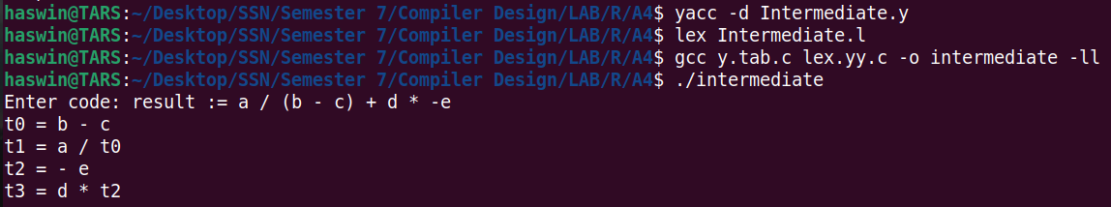

**Learning Outcomes :-**

1. Understand the role of intermediate code in the compilation process.

2. Apply syntax-directed translation rules for generating intermediate code.

3. Implemented lexer and parser components using Flex and Yacc.

4. Generate intermediate code for boolean expressions and logical operators.

5. Handle syntax errors and improve debugging skills in code generation.